Brownsville Independent School District

School-Parent-Student Compact
2020-2021
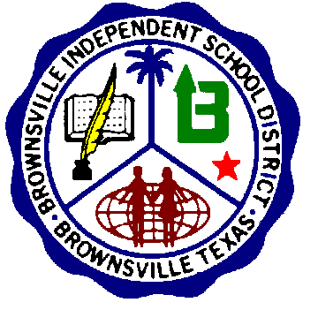
Yturria Elementary
SCHOOL |  | PARENT |  | STUDENT
In recognition that it is the school's responsibility to provide a high-quality curriculum and instruction in a supportive and effective learning environment, the school agrees to: |  | In recognition that it is the responsibility of parents to support their children's learning, the parents of students attending Yturria Elementary School agree to: |  | In recognition that the students have the ultimate responsibility (privilege) of learning, the student agrees to:
1.-Provide a high-quality curriculum in a supportive and effective environment that enables the children served to meet the State’s Student Performance Standards and Campus Curriculum such as Fluency, Benchmarks, Accelerated Reading, and Interactive Journals.  Instruction will include the following learning models: Traditional, Distance Learning, At-Home, Online  2.-Discuss with parents their responsibilities for supporting improved achievement.  3.-Inform parents and students of the purpose of the curriculum and district timelines, students’ performance standards, and the instruction the school will provide to enable student to achieve the state standard. Provide training and support to parents on on-line distance learning platforms.  4.-Schedule Parent/Teacher conferences.  5.-Provide opportunities and/or encourage parents to volunteer whenever possible. Encourage parents to sign up as parent representatives in different committees.  6.-Train teachers and other staff on the latest instructional strategies and methodologies to maintain and improve a positive learning environment in the school.  7.-Have an effective School Safety Plan in place.  8- Maintain safety measures due to Covid 19. |  | 1.-Ensure that their children attend school and be on time every day for all students, and ensure your child participates in distance learning on assigned days.  7:45 – Pick up and Breakfast  8:05 – Instruction Begins  2.-Teach and model respect and responsibility at all times. Set examples for students. Respect school personnel and students.  3.-Ensure that their children do their homework by signing their planner on a daily basis and reviewing their work.  4.-Encourage positive use of their children’s spare time.  5.-Particpate in family reading in order to foster a love for reading.  6.-Read at home for two purposes; to increase their knowledge, and to be an example for them. Ensure on-line platform participation.  7.-Limit the use of electronic devices used by children, such as: TV, computer, tablets, phones and video games.  8.-Support their children in the classroom.  9.-Participate in decisions related to the education of their children and monitor homework, grades, attendance, and discipline through the Home Access Center (HAC). Send doctor excuses.  10.-Attend Parent/Teacher conferences and the Parental Involvement activities. Refrain from negative comments about school on social media. Visit with administration for concerns.  11.-Provide appropriate nourishment and rest for the physical well-being of their children.  12.-Know school safety procedures. Do not send students to school with fever. |  | 1.-Be responsible for his / her own learning and behavior.  2.-Attend school and be on time every day.  7:45 – Pick up and Breakfast  8:05 – Instruction Begins  3.-Be alert and pay attention in class.  4. Attend and participate in all distance learning lessons.  5.-Encourage other students who need help.  6.-Keep homework planner up to date. Take homework assignments home, complete them, and return them to the teacher on time.  7.-Take pride in his/her school, individual work, and personal appearance.  8.-Display respect for himself / herself, school staff, and others at all times.  9.-Particpate in family reading. Incorporate daily Accelerated Reading time so that student reaches AR goal.  10.-Follow all project deadline dates and turn them in on time.  11.-Students not meeting standards on tests and benchmarks must attend tutorials.  1.-Know school safety procedures.
Teacher Signature / Date |  | Parent Signature / Date |  | Student Signature / Date
Date of Parent-Teacher Conference: _______________________
BISD does not discriminate on the basis of race, color, national origin, sex, religion, age, disability or genetic information in employment
or provision of services, programs or activities

